15th March 2023

Greetings, Residents, Family and Friends,

Today we celebrate that the outbreak has been declared over by the Public Health Unit as of 14/03/23 .This makes way for us to share some more Maroba fun for our St Patricks Day Luncheon on Friday in the Manor.

As a precaution we will gradually restore cross suburb activities which is why at the Luncheon residents will be seated together within their own suburb groups.

Our Public Health Unit have advised that while cases in the Hunter are starting to head in the right direction, there are new waves of the virus lurking nearby. Remember the footy has started and the car races drew huge crowds so keep taking personal precautions.

It is vital that if you or a family member are unwell, get tested and report any cases to us. Please don’t visit if unwell or Covid Positive.

**The 2023 Booster is now available and Vaccination Eligibility will depend on date of last vaccine and any recent Covid illness, however we ask that all families go online to our website** [**www.maroba.com.au**](http://www.maroba.com.au) **and separately complete the vaccination consent forms for both Covid and Influenza. We now have our fist clinic date scheduled on 30th March and further Vaccination clinic dates will be announced when we have enough eligible residents with signed consents. These will be managed in conjunction with Whitebridge Pharmacy.**

**Additional Important Information:**

**If you are a regular visitor and need RAT test kits, please see reception for free supplies.**

We continue to offer visiting in communal areas both inside and outside for residents and families. Whilst inside, Surgical masks must be worn. This means you must **NOT** access any drinks machines as this will require removal of your mask. Only residents living within the Manor and Lodge and staff can utilize the Coffee and Drink machines. This is a hygiene issue so please co-operate with this arrangement to protect residents from cross contamination.

If you wish to go outside (which is by far the best option) you may remove your mask if you maintain social distance. If you wish to consume refreshments outside your best option is to bring them. We will keep reviewing Covid conditions and make changes accordingly.

I recently contacted the highest authority in our Local Health District to enquire about masks and visitor numbers as some families are pushing back on our requirements because the NSW Health website states that the listed requirements are recommendations. Let me assure everyone that **there is no plan to soften the current recommendations that visitors SHOULD wear a mask or that visitor numbers should be relaxed**. As we have experienced many outbreaks at Maroba we do know that masks have been beneficial, as has **Hand Hygiene** and **Social Distancing** and we must do all that we can to provide an optimal environment for all.

Social outings and Medical appointments must be booked using our online booking system at least 48 Business hours before the outing. [www.maroba.com.au](http://www.maroba.com.au) Please Note, **Maroba is not able to provide any Medical or Dental appointment escorts** so please do not put us in the awkward position to have to say No.

Visiting will be from 10 am to 4 pm weekdays and weekends. No Appointment necessary during these times and a resident may receive more than 1 visit a day. If you can’t attend during these hours please call reception so we can support your visit.

* **RAT testing continues before entry to the facility and photo evidence of negative result is essential proof.** Do Not carry your RAT with you unless in a sealed bag.
* Wear a **Surgical mask** throughout each visit – **No eating or drinking inside the facility.**
* Check in and out using our Coolguard system in reception. **Wait for the green tick before proceeding. Check with reception or a Staff member if it turns red, do not proceed to your visit.**
* **Only 2 people** may visit inside the building, however if more than 2, outside visiting is the only option. Exceptions may apply for Palliation.
* 1 child (of any age) may attend an inside visit with 1 adult. Keep in mind the children’s playground is open for when you are visiting outdoors.
* **Co-operate with all directions from staff whilst you are visiting Maroba as it is for everyone’s wellbeing and safety.**
* Family members who are nominated Partners in Care for their loved one or those supporting a palliating resident continue their caring and support roles as advised.
* When out and about with a loved one be sure to activate Covid Safe Protocols.
* Spot checks of RAT evidence will take place and if you fail to provide that evidence you will be asked to leave the building immediately.
* If you have concerns with our approach, please call us or if you prefer contact:

Older Persons Advocacy Network (OPAN) on 1800 700 600

The Aged Care Quality and Safety Commission on 1800 951 822

Senior Rights Service 1800 424 079

If you require additional information, please call reception 49350300 during office hours or email [enquiries@maroba.com.au](mailto:enquiries@maroba.com.au).

Yours sincerely,

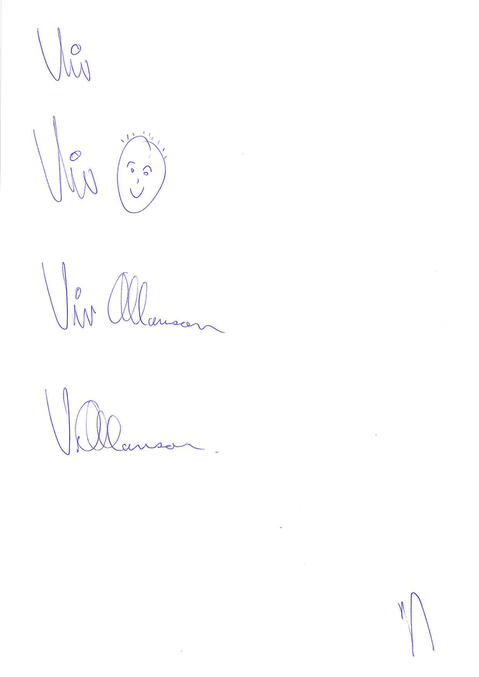

Viv Allanson CEO